**CSCI 677 HW3**

**1.**

**The ”””q1””” solve question a**

**The ”””q2””” solve question b**

**The ”””q34””” solve question c、d**

**2.**

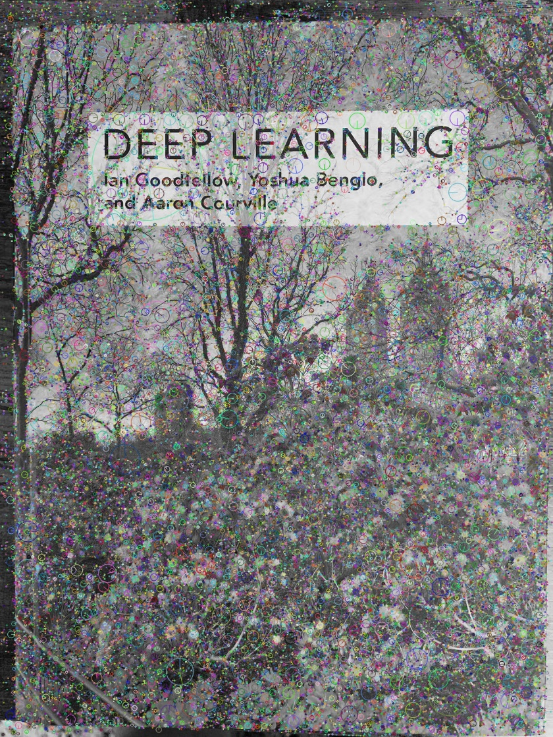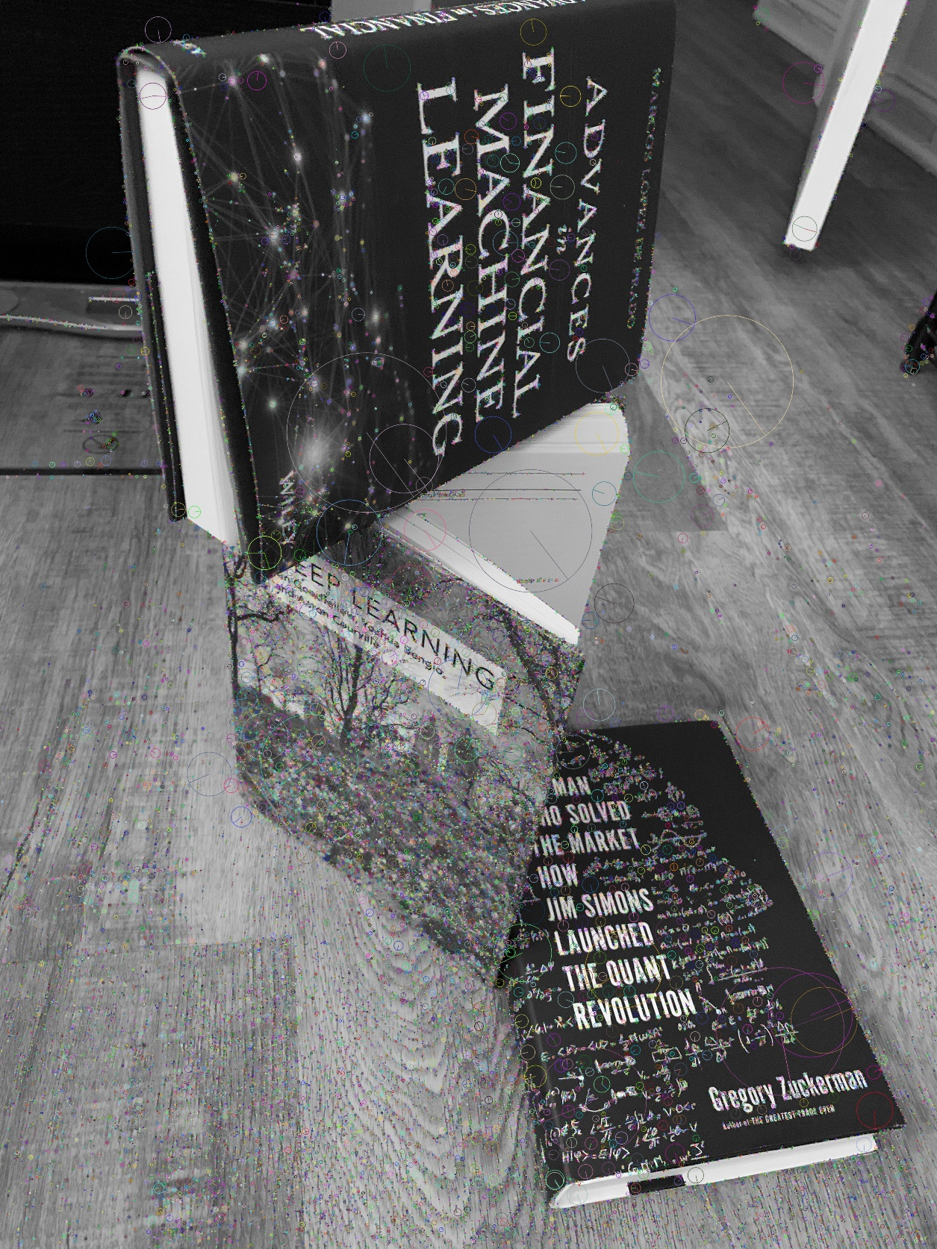

**The number of features detected in dst_0.jpg is 49979**

**The number of features detected in dst_1.jpg is 10625**

**The number of features detected in src_0.jpg is 5259**

**The number of features detected in src_1.jpg is 42457**

**The number of features detected in src_2.jpg is 13004**

B．

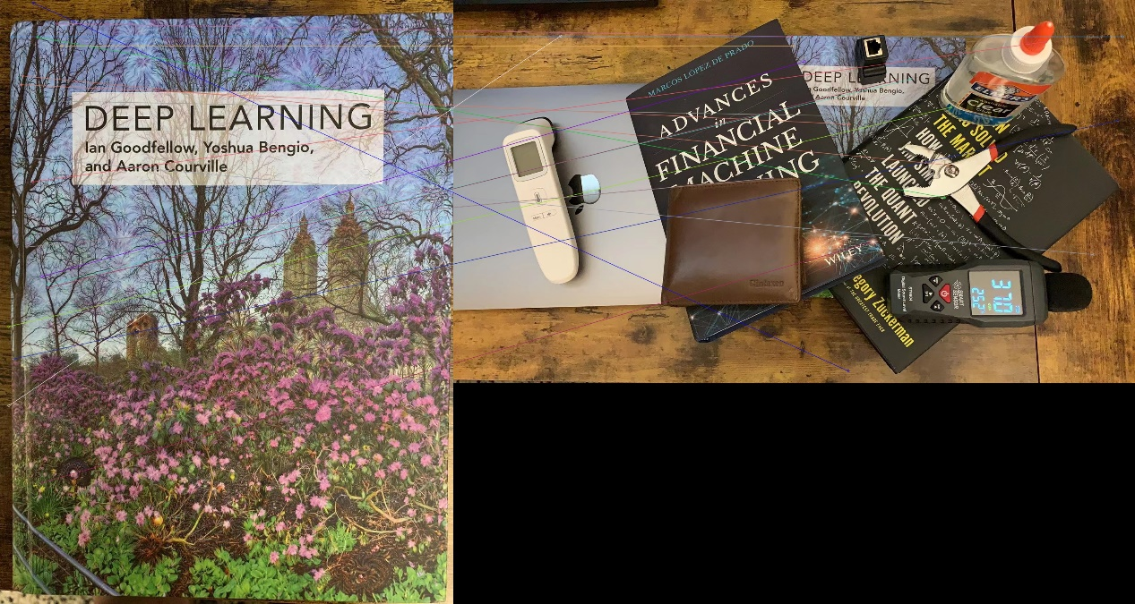

**The number of match pairs for src_0 and dst_0 is 219**

**The number of match pairs for src_0 and dst_1 is 529**

**The number of match pairs for src_1 and dst_0 is 155**

**The number of match pairs for src_1 and dst_1 is 606**

**The number of match pairs for src_2 and dst_0 is 1241**

**The number of match pairs for src_2 and dst_1 is 1047**

**c.**

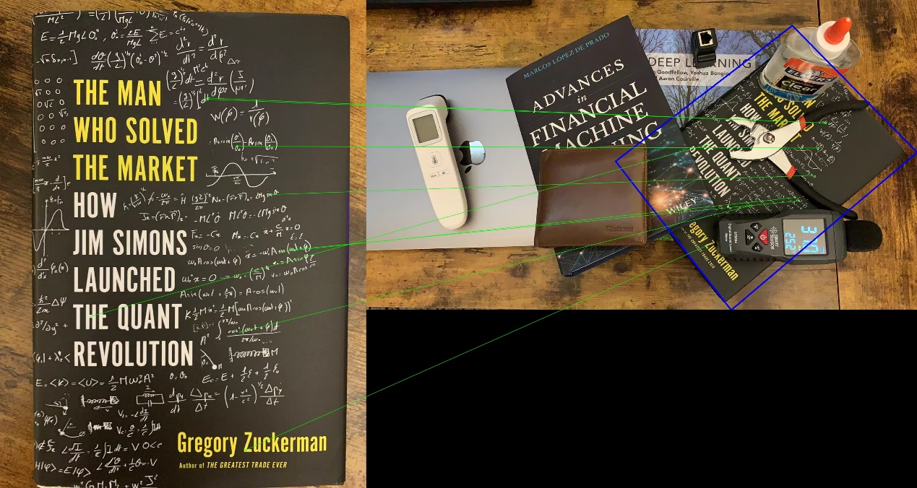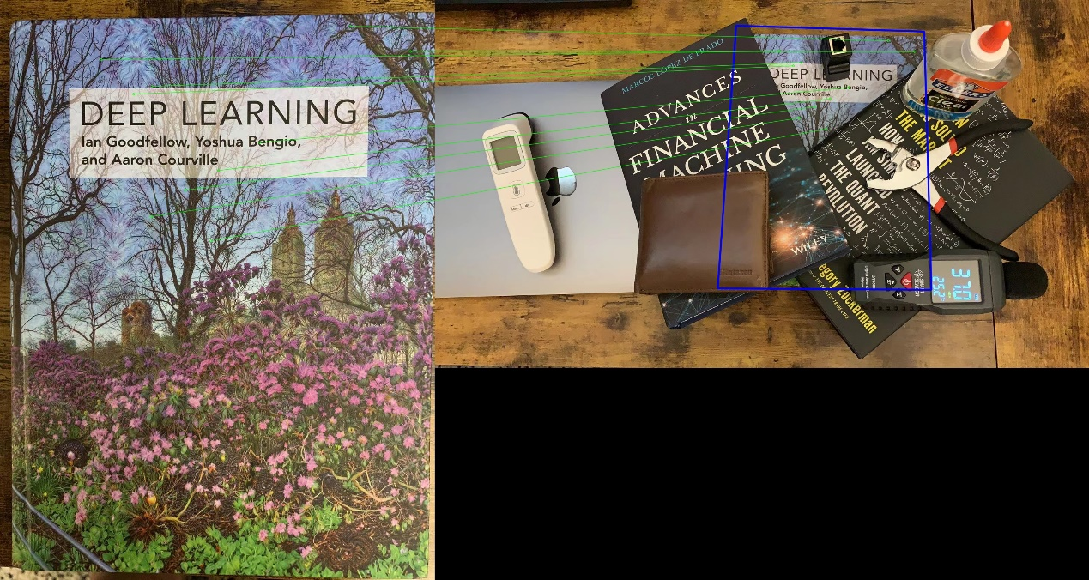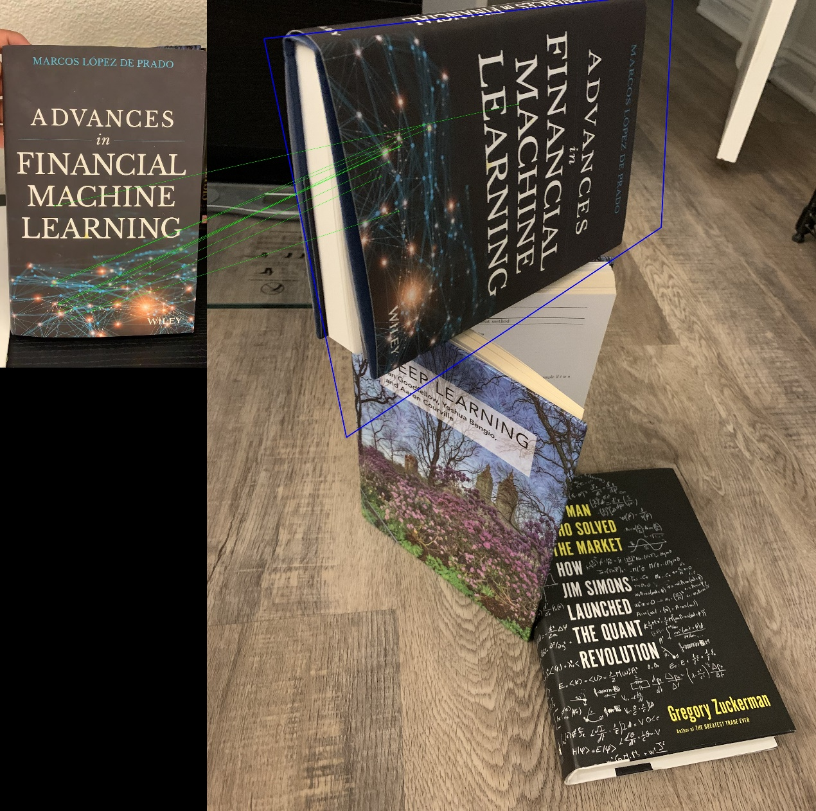

**The number of inliner match pairs for src_0 and dst_0 is 43**

**The number of inliner match pairs for src_0 and dst_1 is 244**

**The number of inliner match pairs for src_1 and dst_0 is 23**

**The number of inliner match pairs for src_1 and dst_1 is 426**

**The number of inliner match pairs for src_2 and dst_0 is 679**

**The number of inliner match pairs for src_2 and dst_1 is 401**

**d.**

**The computed homography matrix for src_0 and dst_0:**

**[[ 3.12372211e-01 -1.18885477e+00 2.31315508e+03]**

**[ 1.32265668e+00 7.41637351e-02 -3.87025732e+01]**

**[ 1.63138240e-04 -2.72969794e-04 1.00000000e+00]]**

**The computed homography matrix for src_0 and dst_1:**

**[[ 3.31032516e-01 7.40079593e-03 4.61445581e+02]**

**[-2.21772821e-01 2.91387716e-01 2.02032390e+02]**

**[-7.14891120e-05 -1.66479324e-04 1.00000000e+00]]**

**The computed homography matrix for src_1 and dst_0:**

**[[ 7.69565873e-01 2.04672231e-01 6.83254280e+02]**

**[ 4.03356545e-01 1.23026436e+00 1.33664296e+03]**

**[-8.57905581e-05 2.04238489e-04 1.00000000e+00]]**

**The computed homography matrix for src_1 and dst_1:**

**[[ 4.53047806e-01 -8.94046373e-02 8.84443983e+02]**

**[ 1.46957073e-02 3.94035344e-01 7.54682065e+01]**

**[ 1.38368044e-05 -6.97128184e-05 1.00000000e+00]]**

**The computed homography matrix for src_2 and dst_0:**

**[[ 8.26586461e-01 -1.40561422e-01 1.42082716e+03]**

**[ 4.98119733e-02 1.63322961e-01 2.37010171e+03]**

**[ 4.61400604e-05 -1.82229143e-04 1.00000000e+00]]**

**The computed homography matrix for src_2 and dst_1:**

**[[ 2.11957612e-01 -3.92439093e-01 1.48597026e+03]**

**[ 3.10456637e-01 2.58301888e-01 8.99926830e+01]**

**[-6.69603689e-05 -3.47699306e-05 1.00000000e+00]]**

**3.**

**This method works well. It can locate objects in given images.**

**It do not work equally well on the different examples.**

**I make this conclusion by calculate the average error for the top 10 minimal error between projected source points and destination points.**

|  |  |  |
| --- | --- | --- |
| **Source** | **Destination** | **Average error** |
| **src_0** | **dst_0** | **0.3460063338279724** |
| **src_0** | **dst_1** | **0.2416616976261139** |
| **src_1** | **dst_0** | **0.8064872026443481** |
| **src_1** | **dst_1** | **0.11277048289775848** |
| **src_2** | **dst_0** | **0.22984850406646729** |
| **src_2** | **dst_1** | **0.12075662612915039** |

**We can see that the performance for pairs whose destination images is dst_1 is better than dst_0. It might be caused by the reason that the books in dst_1 are placed flat on the table, so the shape of books stay rectangle.**

**Part of differences between these pairs might also be affected by the sift feature for each objects.**